
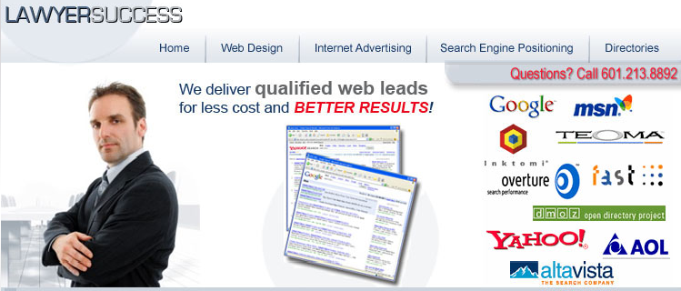
LawyerSuccess.com has over 8 years of experience in law firm Internet marketing and has worked with several prominent
multi-million dollar brands such as WestLaw, Findlaw, Divorce.com USlegalforms.com, LawStore.com, RealAttorney, SearchLaw.com, AttorneyFind.com and many other top legal consumer websites.

Put our competency to work for you and let us build your web traffic and increase your law firm’s website overall performance.

LawyerSuccess.com enjoys a 95% renewal rate!!!

Services Offered:
- Website Design – Dramatically improve your visit to lead conversion ratio by allowing our experts to modify or redesign your existing website.
- Search Engine Optimization (SEO) – Our SEO experts can improve your search engine positioning by redesigning OR working with your existing website!
- Optimized Content – Custom content development is available to effectively attract new web visitors or target specific clientele.
- Google Advertising/Keyword Research
- Link Popularity – 85% of search placement depends on your website’s link popularity. We can build your link popularity and dramatically improve your rankings.
- Attorney Directory Network – We receive volume discounts on all major lawyer directories. Call us and get what you want for less!
- Lead Generation Services – 60,000 guaranteed leads per month are produced through our network of affiliate websites. We guarantee phone calls and emails.

For a free consultation please call James Greenier at 769-218-6099 or email us at info@lawyersuccess.com. You may also visit our website http://www.lawyersuccess.com for additional information.

